|  |  |  |
| --- | --- | --- |
| **Species** | **Parous rate** | **Sac rate** |
| aconitus | 0.667 | 0.446 |
| barbirostris s.l. | 0.555 | 0.168 |
| dirus s.l. | 0.567 | 0.347 |
| epiroticus | 0.292 | 0.330 |
| hodgkini | 0.000 |  |
| jamesii | 0.738 | 0.427 |
| kochi | 0.708 | 0.720 |
| maculatus s.l. | 0.542 | 0.499 |
| minimus s.l. | 0.684 | 0.595 |
| philippinensis | 0.600 | 0.663 |
| sinensis | 0.247 | 0.160 |
| tessellatus | 0.522 | 0.585 |
| umbrosus | 0.000 |  |
| vagus | 0.757 | 0.499 |

Parous rates and sac rates from (Charlwood et al., 2016)

CHARLWOOD, J. D., NENHEP, S., SOVANNAROTH, S., MORGAN, J. C., HEMINGWAY, J., CHITNIS, N. & BRIET, O. J. T. 2016. 'Nature or nurture': survival rate, oviposition interval, and possible gonotrophic discordance among South East Asian anophelines. *Malaria Journal,* 15.

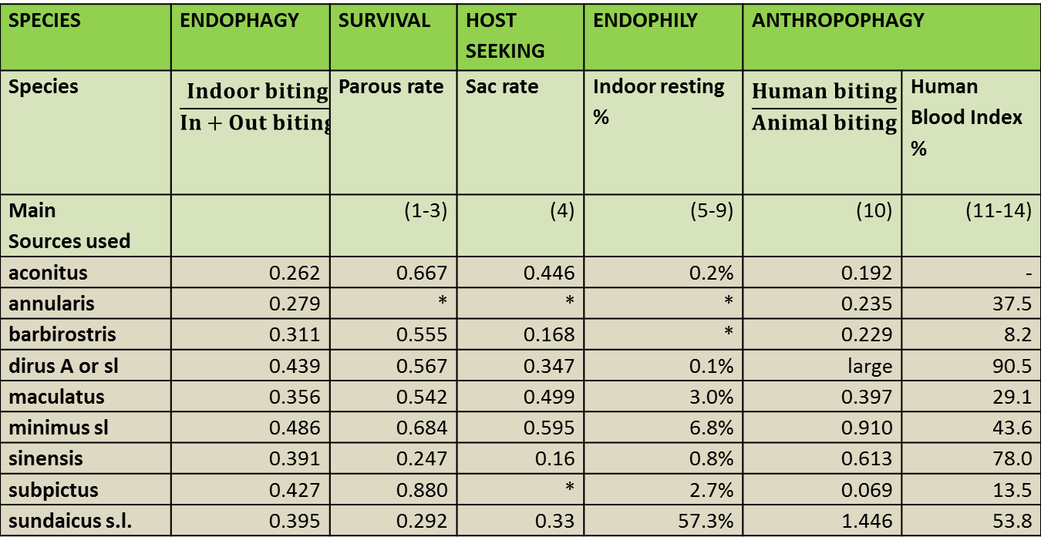

1. Bashar et al. 2012. Parasit. Vectors. 5:39

2. Catangui. 1971. Southeast Asian J Trop Med Public Health 2:384-92

3. Charlwood et al. 2016. Malar J 15:356

4. Charlwood et al 1997. Bull Entomol Res 87:445-53

5. Chatterjee S, Chandra G. 2000. Jpn. J. Trop. Med. Hyg. 28:177-81

6. Dutta et al.. 1996. Southeast Asian J Trop Med Public Health 27:378-81

7. Elyazar et al. 2013. Adv. Parasitol. 83:173-266

8. Ismail et al. 1973. WHO/MAL/73.810, World Health Organization, Geneva

9. Mahmood, Reisen WK. 1981. Mosquito News 41:41-50

10. Manh, et al. 2010. Malar J 9:259

11. Nanda, et al. 2000. J. Am. Mosq. Control Assoc. 16:199-205

12. Ndoen, et al. 2012. ISRN Public Health 2012:1-5

13. Ritthison et al.. 2014. J Vector. Ecol. 39:361-71

14. Singh et al.. 1999. J. Am. Mosq. Control Assoc. 15:283-90

15. Singh et al.. 1996. Bull. Entomol. Res. 86:475-9

16. Tainchum et al. 2014. J Vector. Ecol. 39:424-36

17. Tananchai et al. 2012. Parasit. Vectors. 5:211

18. Trung, et al. 2005. Trop. Med. Int Health 10:251-62

19. Van Bortel et al.. 2009. Malar J 8:248

20. Wharton. 1951. Bull Entomol Res 42:1-21